ERIC Thesaurus Worksheet
Remember the card catalog of yore, where you could look up a subject and find all of the books in the library on that subject? That process was made possible by the use of subject headings, which are standardized terms that were applied to all of the research on a particular topic.
Subject headings are incredibly useful, but it can sometimes be difficult to figure out which subject heading to use. The ERIC database has a great tool called the ERIC thesaurus to help you identify subject headings. To use it, click on the "Thesaurus" link at the top of the screen in the ERIC database:
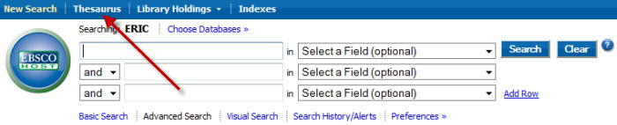
Type your search term into the "Browse" box, and the thesaurus will tell you which subject headings to use. For example, the thesaurus suggests using the subject "Individualized Instruction" rather than "Differentiated Instruction."
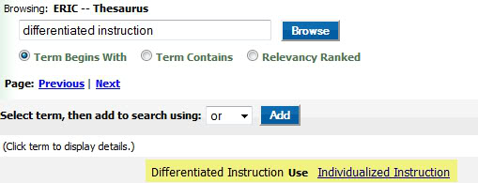
Doing a subject search for "Individualized Instruction" in ERIC retrieves research related to personalized education, even if the phrase "individualized instruction" does not appear in the articles at all!
Clicking on the underlined phrase “Individualized Instruction” within the ERIC thesaurus brings up a list of related terms which you can also use in your search:
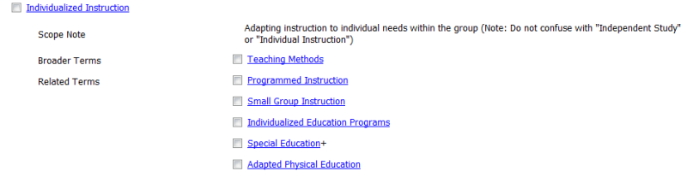

ERIC Thesaurus Search Results
Search the ERIC thesaurus for your concepts, and record the suggested subject headings below.
Concept #1 | Subject headings suggested by the ERIC thesaurus
Concept #2 | Subject headings suggested by the ERIC thesaurus
Concept #3 | Subject headings suggested by the ERIC thesaurus
Concept #4 | Subject headings suggested by the ERIC thesaurus

Finally, remember the terms AND and OR? You can use them with subject headings, too. For example, a search for the subject headings "Individualized Instruction" AND "Gifted" AND "Elementary Education" in ERIC retrieves 49 highly relevant results. When searching online databases, use the word AND between concept terms and the word OR between synonyms/related terms, like this:
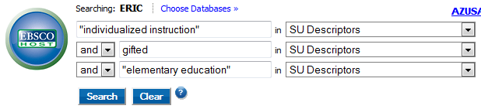
Use the subject headings you identified above to search the ERIC database, and record your findings below.
Search Terms Used | # of Results
Search #1

Search #2

Search #3

